2023電子物理系專題競賽報名表

參賽者:___________________ 學號:________________
本人於112學年第一學期 註冊於電子物理系
□學士班 ___ 年級

聯絡電話:_____________(手機)
電子郵件: __________________________

專題題目:________________________________________________

________________________________________________

PS. 參賽者必須為該專題壁報第一作者，且必須於各規定時間內完成報名、壁報檔案繳交、與壁報展示講解。

共同作者:________________________________________________
(依序填寫)

指導老師:_______________
論文摘要請依下一頁格式處理(可以用中文書寫)並與此報名表同時繳交。(9/11前)

填寫人： （簽名） 年 月 日，
證明以上所填寫資料均屬實。

Template for abstracts preparation for the Poster
(Times font, 16pt, bold, centered)

W. C. Chou¹, B. Second¹, and C. Third² (Times font, 14pt, normal, centered)

¹Department of Electrophysics, National Chiao Tung University, Hsinchu, Taiwan
² Institute of Physics, National Chiao Tung University, Hsinchu, Taiwan
(Times font, 14 pt, Italic, centered)

e-mail address of submitting author (Times font, 14 pt, normal, centered)

Please, include in this space a short abstract. Use Times font, 14 pt. Justified left and right. All margins are 2.0 cm. Underline the author who makes the presentation. The maximum length including figures and references is one page (A4 format), and data size should be smaller than 3MB. The authors are responsible for the content and style of the contribution. No editing or re-typing will be carried out.
The abstract may include figures. Book of Abstracts will be printed in black and white. Please ensure the legibility of your pictures without color. Equation numbers must be in parentheses and placed flush with right-hand margin.
List and number all references at the end of the abstract. When referring to them in the text, type the corresponding reference number between brackets as shown at the end of this sentence [1].
[1] A. Morning, Physical Review B 87, 000001 (2013).

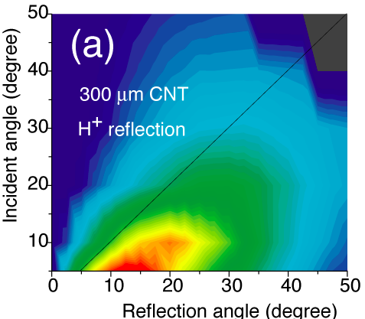
A caption should be attached to each figure (Times font, 14pt, normal).

